Challenge
LO4 – Realizing
Malamski,Dimitar D.S.
mitemalamata@gmail.com

Contents
Contents 1
Introduction 2
Sprints 2
Sprint 6 2
Evidence 1 - Designing a Multi-Label Recommendation Pipeline 2
Sprint 5 3
Evidence 1 - Integrating the Selected Models into the Final Recommendation Pipeline 3
Sprint 4 4
Evidence 1 - Training and Validating the Style and Type Classifiers 4
Evidence 2 - Applying Fine-Tuning and Validating Generalization 5
Evidence 3 - Improving the Models with Targeted Extra Data 6
Sprint 3 6
Evidence 1 - Preparing and structuring the image dataset 6
Evidence 2 - Applying image preprocessing and augmentation 7
Evidence 3 - Creating train, validation, and test splits using a Python script 8
Evidence 4 - Implementing DataLoaders for batch processing 9
Sprint 1 & 2 9

Introduction
This document presents the evidence for Learning Outcome 4 ( Realizing ) in my Challenge project – Outfit Recommendation System. The purpose of this document is to show how I demonstrated this learning outcome by preparing and preprocessing data, applying machine learning techniques, and validating model performance using industry-standard evaluation metrics. The evidence is organized by sprint, with each section describing the activity, the result, and why it is relevant to the learning outcome.

Sprints

Sprint 6

Evidence 1 - Designing a Multi-Label Recommendation Pipeline
What this evidence is
This evidence shows how I redesigned the style prediction and recommendation approach from single-label classification to multi-label classification.
What I did
After communication with my teacher, I realized that fashion styles are not always separated clearly. Some clothing items can belong to more than one style at the same time. For example, an item can look both gothic and streetwear, or both sporty and streetwear. Because of this, I decided that the style model should not always be forced to choose only one style.
To improve this, I designed a multi-label approach for the style classifier. Instead of predicting only one final style, the model can now return multiple possible style labels. This gives the recommendation system more flexibility, because it can search for outfit items from more than one matching style direction.
I also designed the recommendation pipeline so that the multi-label style prediction can work together with the clothing type classifier and CLIP ranking. The type classifier is still used to avoid recommending the same clothing type as the uploaded item, while CLIP visual similarity is used to rank the best matching recommendation candidates.
Result
This resulted in a more flexible recommendation design. The system is no longer limited to one predicted style only. Instead, it can use multiple possible styles and recommend items based on a wider style context. This is useful because fashion items often combine different aesthetics, and a strict single-style prediction can remove useful recommendation options.
The first multi-label recommendation test showed that simply using multiple styles as a wider filter was not enough, because the recommendations could become less visually coherent. Because of this, I combined the multi-label approach with CLIP ranking. This improved the recommendation quality, because the system could use multiple style directions while still selecting visually similar items.
Why this is relevant to the Learning Outcome
This demonstrates Designing because I redesigned an important part of the AI solution based on the limitations of the previous model and feedback from my teacher. I did not only change the model output, but also changed how the recommendation pipeline uses style information. The design became more suitable for the fashion domain, because it allows overlapping styles and supports more flexible outfit recommendations.
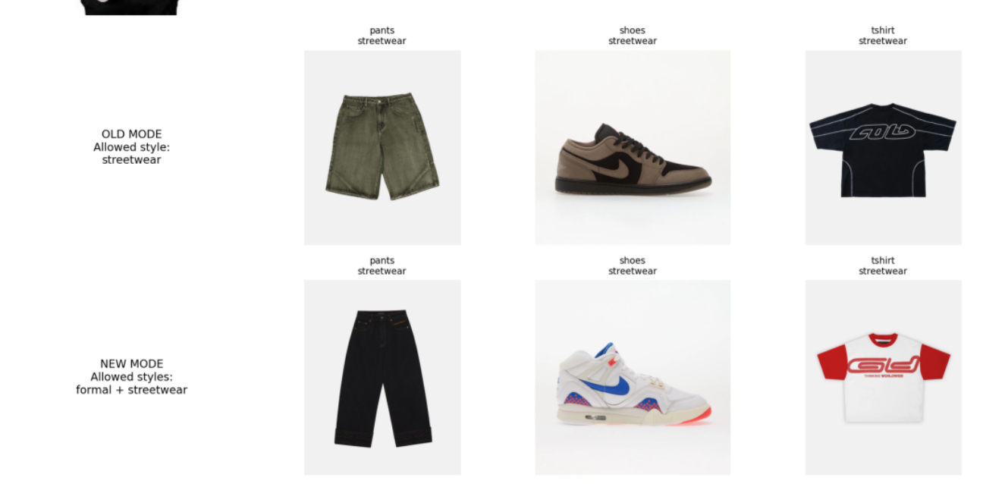

Sprint 5

Evidence 1 - Integrating the Selected Models into the Final Recommendation Pipeline
What this evidence is
This evidence shows how I integrated the selected style classification model and recommendation ranking method into the final recommendation pipeline.
What I did
After comparing multiple style classification architectures, I selected MobileNetV3 Large because it achieved the strongest real-world performance. I also evaluated CLIP image embeddings and found that they improved visual coherence and overall recommendation quality compared to the previous ResNet34 embedding approach.
I integrated both selected components into the recommendation system. The final pipeline uses the MobileNetV3 Large style classifier, the improved ResNet34 clothing type classifier, CLIP image embeddings, cosine similarity ranking, and confidence safeguards. After integrating the components, I evaluated the complete system using the 32-example recommendation evaluation framework.
Result
The final pipeline achieved a style prediction accuracy of 0.65625 and a type prediction accuracy of 0.9375 on the evaluation subset. Visual coherence improved from 1.3750 to 1.6250, while overall recommendation quality improved from 1.40625 to 1.5625. The number of bad recommendations also decreased from 6 to 1.
These results showed that the selected models worked effectively together and improved the overall recommendation quality of the system.
Why this is relevant to the Learning Outcome
This demonstrates Realizing because I implemented the selected machine learning components, integrated them into a working recommendation pipeline, and validated the final solution using structured evaluation metrics. The effectiveness of the implementation was measured through both automatic and manual evaluation, ensuring that the final system was tested rather than assumed to work.
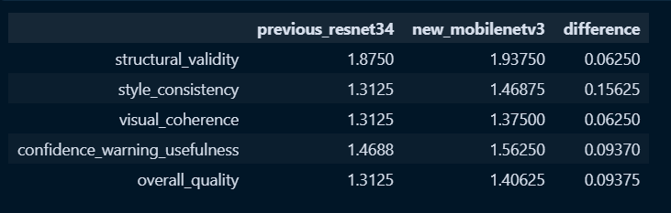

Sprint 4

Evidence 1 - Training and Validating the Style and Type Classifiers
What this evidence is
This evidence shows how I trained and validated the style and clothing type classifiers.
What I did
I trained two ResNet34-based classifiers using transfer learning. One model was trained to predict the fashion style, and the other model was trained to predict the clothing type. I validated the models using accuracy, classification reports, F1-scores, and confusion matrices. For the clothing type model, I also created a small external test set to check if the perfect internal result was realistic.
Result
The style classifier achieved 0.8417 test accuracy and a macro F1-score of 0.84. The clothing type classifier achieved 1.00 accuracy on the internal test set and 0.90 accuracy on the external test set. These results showed that both tasks were learnable, but clothing type classification was more reliable than style classification.
Why this is relevant to the Learning Outcome
This demonstrates Realizing because I applied machine learning techniques and validated the models using industry-standard evaluation metrics. The results showed whether the prepared dataset and preprocessing pipeline were suitable for model training.
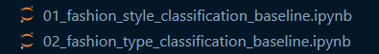

Evidence 2 - Applying Fine-Tuning and Validating Generalization
What this evidence is
This evidence shows how I tested partial fine-tuning as an improvement strategy for the style classifier.
What I did
After the baseline style classifier, I tried to improve the model by unfreezing the last ResNet34 block, layer4, together with the final classification layer. This allowed the model to adapt more to fashion-specific visual features instead of only training the final layer.
Result
The fine-tuned model improved on the curated test set, reaching 0.9417 accuracy compared to the baseline result of 0.8417. However, the real-world accuracy decreased from 0.4750 to 0.4250. This showed that fine-tuning improved performance on clean curated images, but did not improve generalization to realistic images.
Why this is relevant to the Learning Outcome
This demonstrates Realizing because I applied a machine learning improvement technique, tested it, and validated the result using evaluation metrics. It also showed that model improvement must be judged on realistic validation data, not only on curated test accuracy.
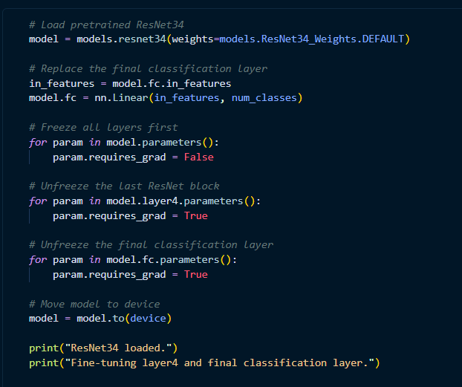

Evidence 3 - Improving the Models with Targeted Extra Data
What this evidence is
This evidence shows how I improved the models by adding targeted extra data based on earlier evaluation results.
What I did
After testing the models on real-world images, I noticed that the models struggled with certain realistic cases. Because of this, I added extra targeted training data. For style, I added more examples for weak or confusing categories, especially streetwear. For clothing type, I added more real-world-like examples such as worn jackets, oversized tshirts, pants, and shoes in varied conditions.
Result
The style model improved from 0.4750 real-world accuracy to 0.6000. The clothing type model improved from 0.7500 real-world accuracy to 0.8875. This showed that improving the dataset helped the models generalize better to realistic images.
Why this is relevant to the Learning Outcome
This demonstrates Realizing because I prepared extra data, used it in the training process, and validated the improvement with measurable results. The improvement was tested using real-world evaluation metrics, not only assumed from the dataset changes.

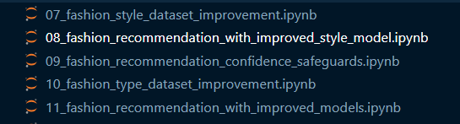

Sprint 3

Evidence 1 - Preparing and structuring the image dataset
What this evidence is
This evidence shows how I prepared and structured the image dataset so that it could be used for machine learning.
What I did
I organized the dataset into multiple stages, including raw, cleaned, metadata, and final split folders. I manually reviewed the collected images to ensure consistency in terms of style labels, visibility, and overall quality. I also ensured that each image followed the defined dataset rules, such as containing a single dominant clothing item and having a clear visual representation. In addition, I generated a metadata file ( labels.csv ) that stores information about each image, including filename, style, and clothing type. As a starter, I collected a total of 10 images per clothing type in each style and later expand it to up to 50 images per type.
Result
This resulted in a clean, structured, and well-documented dataset that is suitable for machine learning experiments. The dataset organization also supports reproducibility and future extensions of the project.
Why this is relevant to the Learning Outcome
This demonstrates realizing because I prepared the data according to quality criteria and structured it in a transparent and repeatable way, making it suitable for model training.
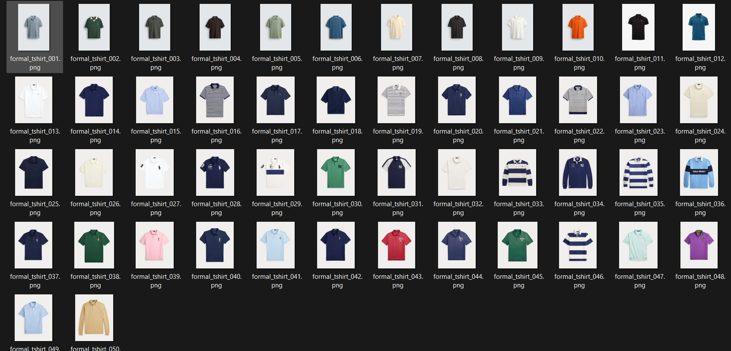

Evidence 2 - Applying image preprocessing and augmentation
What this evidence is
This evidence shows how I applied preprocessing and augmentation techniques to prepare the image data for model training.
What I did
I applied a set of transformations to the images using PyTorch. All images were resized to a fixed size of 224x224 and normalized using standard ImageNet mean and standard deviation values. For the training set, I also applied light data augmentation in the form of random horizontal flipping. This was done to slightly increase the variability of the dataset without changing the class labels.
Result
This preprocessing pipeline ensured that the images were in a consistent format suitable for the pretrained model. The augmentation also helped improve the model’s ability to generalize, despite the small dataset size.
Why this is relevant to the Learning Outcome
This demonstrates realizing because I applied systematic preprocessing techniques to transform raw image data into a format that is appropriate for machine learning.
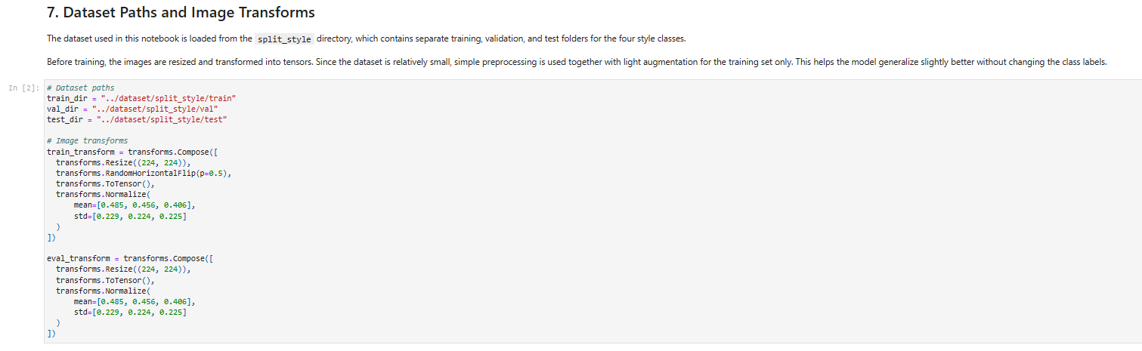

Evidence 3 - Creating train, validation, and test splits using a Python script
What this evidence is
This evidence shows how I created a structured dataset split for training, validation, and testing.
What I did
I developed a Python script to automatically split the cleaned dataset into training, validation, and test sets. The script ensured that each style class was evenly distributed across the splits, maintaining a balanced dataset. The final structure followed a standard image classification format, where each split contains separate folders for each class. This allowed the dataset to be directly used with PyTorch’s ImageFolder functionality.
Result
This resulted in a consistent and reproducible dataset split that supports fair model training and evaluation. It ensured that the evaluation process is reliable and not biased toward a specific subset of the data.
Why this is relevant to the Learning Outcome
This demonstrates realizing because I implemented a structured and repeatable process for preparing the dataset for machine learning experiments.
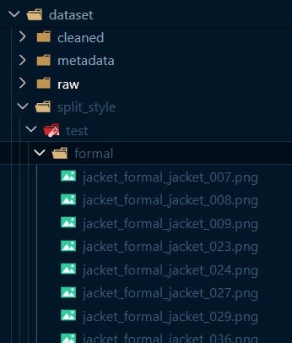

Evidence 4 - Implementing DataLoaders for batch processing
What this evidence is
This evidence shows how I implemented batch-based data loading for efficient model training and evaluation.
What I did
I used PyTorch’s DataLoader class to load the training, validation, and test datasets in mini-batches. I configured the training DataLoader to shuffle the data in order to improve model learning, while keeping the validation and test DataLoaders consistent without shuffling. I also defined an appropriate batch size to balance training efficiency and computational constraints.
Result
This resulted in an efficient and scalable data pipeline that allows the model to process the dataset in batches. It improved training performance and ensured that the data was handled consistently across different stages of the pipeline.
Why this is relevant to the Learning Outcome
This demonstrates realizing because I implemented a technical solution for handling data during model training in a structured and efficient way.
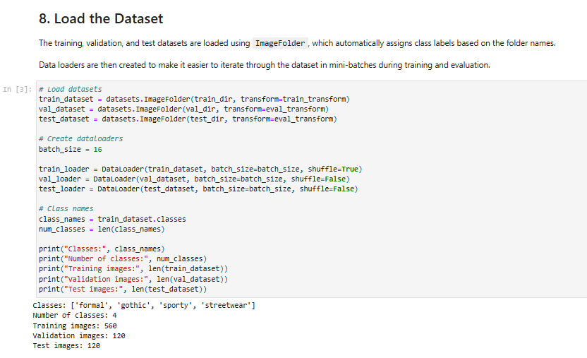

Sprint 1 & 2
There was no work done in those sprints, since the projects starts from Sprint 3.

